Topic Exploration Pack

Appreciation and Depreciation

Activity 1
Complete the table (the first row has been done for you).

To | Multiply by
Increase by 12% | 1.12
Increase by 25%
Decrease by 15%
 | 1.06
 | 0.92
Increase by 4.5%
Decrease by 7.2%
 | 0.875
 | 1.093
Add 4% to a quantity
Take 17% from a quantity
Increase by 10%
Increase by 1%
Decrease by 10%
Decrease by 1%
 | 0.5
 | 2.0

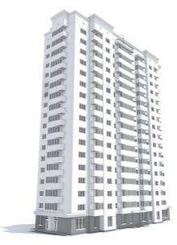
Activity 2
- A flat is valued at £85 000. It is expected to increase in value by 6% each year.
Find the expected value of the flat after a year.

- A new van costs £18 000. It depreciates by 20% per year. Find its value after 1 year.

- A woman invests £5000 in a bank account which pays 4% interest per year.
Find the value of the investment in 5 years’ time.

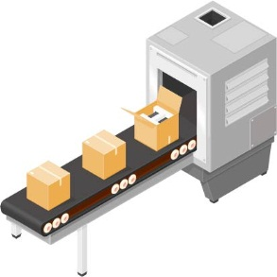
- The value of the machinery in a manufacturing plant depreciates at a rate of 8% per year. If the original value of the machinery is £65 000, find its value 10 years later.

- A new car costs £15 780. It is expected to depreciate by 20% per year for
the first two years, then by 2% per year thereafter.
Find the value of the car after:
  - 2 years,
  - 6 years.
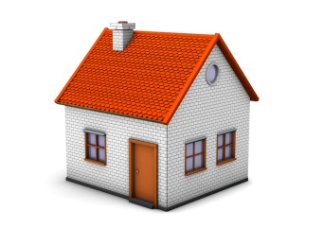

- A house was bought for £165 000. Two models are suggested for its appreciation.
- Model A is that the value increases at a rate of 4% per year.
- Model B is that the value increases by £8000 per year.

- Find the expected value of the house in each of the following 5 years under each model.

The house was actually valued for each of the next five years (to the nearest thousand pounds) as follows:
Years after start | Value
0 | £165 000
1 | £169 000
2 | £176 000
3 | £184 000
4 | £196 000
5 | £203 000

- Draw a single graph to compare the expected values under each of the two models with the actual valuations.

- Explain which model you think is better over this 5 year period.

- Explain which of the two models you think would be better in the long term, assuming that house prices continue to appreciate.

Activity 3
- A car, originally valued at £7240, depreciates in value to £5795 over a period of 1 year. Find the annual percentage rate of depreciation.

- A painting cost £420. A year later its value is £460.
Find the annual percentage rate of appreciation.

- A boat was purchased for £23 500 in 2006. Ten years later in 2016, it was
valued at £14 100. Find the average annual percentage rate of depreciation.
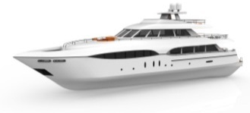

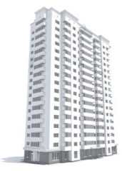
- An apartment was bought for £185 500 in January 2010. In January 2015, it was
valued at £217 600. Work out the average annual percentage rate of appreciation.

- Mark bought a computer for £725. Three years later, he sold it for £120. Find the average annual percentage rate of depreciation.

- Maya invests £1000 in a bank account. Twenty years later her investment has
increased in value to £1540. Calculate the average annual percentage rate of
appreciation.

- On a particular date in 1996, the price of gold was $400 per ounce. On the same date in 2011 it was $1400 per ounce. Find the average annual percentage rate of appreciation.
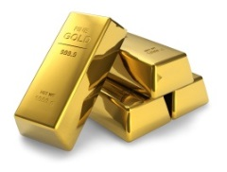

- On the same date in 2014, it was $1210 per ounce. Find the average annual percentage rate of depreciation from 2011 to 2014.

- A van was bought for £8500 and sold a number of years later for £6300. If the average annual percentage rate of depreciation was 9.5%, work out how many years later the van was sold.

- A rare stamp was bought for £400 in 2005. A few years later it was valued at £1000.
The average annual percentage rate of appreciation was 16.5%. In which year was the valuation carried out?

- A motorbike was bought for £3750. During the first year after it was bought it depreciated by 25%.
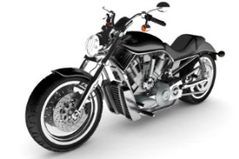
- Find the value of the motorbike after 1 year.

For the following four years it depreciated at a rate of 12% per year.
- Work out the value of the motorbike after 5 years.

- Calculate the average annual percentage rate of depreciation over the whole of the 5 year period.

